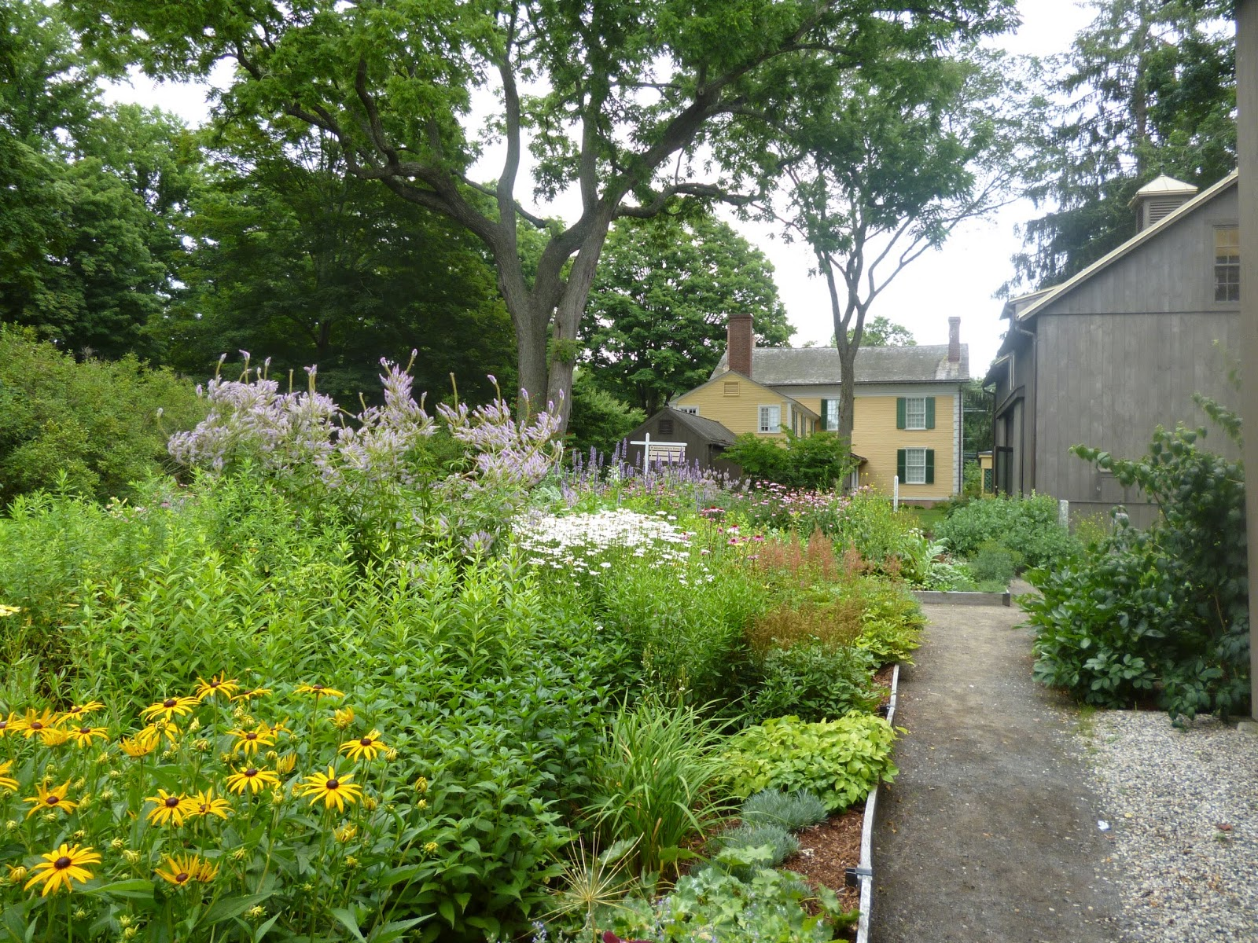

***Spend a Day at the Florence Griswold Museum***

**The beautiful Florence Griswold Museum, gardens and grounds in Old Lyme, Ct. is our destination on this day. “In 1899 Miss Florence Griswold opened her family home to artists searching for a quiet country retreat…” There is much to see at the museum- something for everyone**

***\*October’s special exhibit on the grounds, “A Wee Faerie Village”***

***\* Kreible Gallery “Three Women, Three Artists, Three Centuries”***

***\*The Florence Griswold House- Take a self- guided tour of the home and boarding house where artists lived and painted***

***\*visit the Landscape Center, the Chadwick Studio. Café Flo and the Lyme Art Association. Bring a sketchbook or watercolors.***

**When: Thursday, Oct. 9 (bus will board at 9 and return at 5 PM)**

**Where: leaves and returns from Portsmouth Arts Guild**

**------------------------------------------------------------------------------------------**

**I would like to register for_______________________________________________________________**

**Name___________________________________ _________________Phone____________________________**

**Email__________________________________________________Amount enclosed$_________________**

**Return to: PAG workshops, P.O. 1181, Bristol, 02809 or contact Susan Conant**

**newportsquared@yahoo.com**